Social capital and the success of economic sanctions

**Abstract**

What determines the success of economic sanctions? Although numerous studies explore the formal institutional characteristics of sanctioned countries and their effects on sanction effectiveness, few examine informal social institutions such as trust, membership, or, more broadly, social capital. Using the latest Threat and Imposition of Economic Sanctions data and cross-national World Values Survey data, we examine how trust and social capital in sanctioned countries affect target governments’ ability to endure the costs of economic sanctions. Our findings support our theory that sanctions are less likely to be effective when imposed on countries with high trust, membership, and confidence in political institutions.

**Keywords**

economic sanctions, social capital, North Korea, political behavior

Word count: 7884

**Introduction**

When North Korea conducted its first underground nuclear test in 2006, the United Nations (U.N.) adopted resolution 1718, acting unanimously under Chapter VII of the UN Charter. Between the period of October 2006 and September 2017, six nuclear tests and the economic sanctions have been strengthened every time. The initial sanctions targeted Kim Jong-il and supporters for the nuclear weapons program by restricting their ability to travel, prohibiting the flow of luxurious goods, and freezing their financial accounts abroad.[1]

These targeted sanctions have not curbed Pyongyang’s nuclear ambitions. Policymakers in South Korea have been discussing ways to increase its effectiveness since North Korea’s nuclear tests on January 6th and September 9th, 2016. The South Korean Ministry of Unification announced one such effort—closing the Kaesong industrial complex—in February 2016. This action was part of a general strategy to widen the number of North Koreans afflicted by sanctions in the hope of inciting the populace to force Kim Jong-un to amend his policies.[2]

When a sender imposes a sanction, we can expect that it will damage targeted states’ economies and increase the political and economic costs of a leader in targeted states. Thus, it is essential whether a sanction is costly for a leader to be successful. However, sanctions sometimes are not costly. For instance, when North Korea confronted economic sanctions, its leader declared that he regards sanctions as an act of war (Frank 2006). Then, citizens are likely or mobilized to support the leadership in the face of foreign coercion (Cortright and Lopez 2006).

We ask whether and under what circumstances economic sanctions succeed. Firstly, it is plausible that shifting the burden of sanctions might rouse the general populace to confront its government and force a policy change, particularly if sanctions were imposed for reasons seemingly unrelated to ordinary citizens. In other words, a populace can be mobilized from the bottom up if people believe they are being afflicted by a kind of tariff imposed only because its leaders behave a certain way. Plausibility notwithstanding, however, we argue that one important construct can prevent this strategy from succeeding: social capital.

Social capital embodies collective values such as trust, membership, and confidence in institutions that unite people. When assessing sanctions, social capital matters as sanctions’ success may depend on the likelihood to mobilize an afflicted populace from the bottom. When the nature of a nation’s social capital is such that it can unite a populace to demand policy changes from its leader, we posit that an *opposition effect* favors sanctions success. When the nature of social capital is such that it unites the populace behind a leader who defies sanctions, we posit that a *rally effect* assures that more comprehensive sanctions will fail.

Drawing from two datasets spanning 1981 to 2005—the Threat and Imposition of Sanctions (TIES) and the World Values Survey (WVS)—we investigate whether the *opposition effect* or the *rally effect* of social capital dominates a populace’s response to sanctions. We empirically show which of the two contradictory effects we can observe using data. If social capitals have opposite effects on economic sanctions, a populace is likely to mobilize effectively against their leader to let him comply with sanctions. Otherwise, a sanctioned country’s populace shares high degrees of interpersonal trust, membership in social or political organizations, confidence in key institutions, and they support the leader to fight against economic sanctions.

This paper proceeds as follows. The second section studies literature related to social capital, and the third explains the theoretical effects of social capital in response to sanctions. The fourth section describes data collection, variables, and methods. The fifth explains empirical findings, and the sixth section concludes.

**Literature Reviews**

*Social capital*

Political scientist Robert Putnam (1993; 1995; 2000) introduced the concept of social capital as “features of social organizations such as networks, norms, and social trust that facilitate coordination and cooperation for mutual benefit” (65). Social capital remains much-discussed in political science and is particularly used to explain such phenomena as political participation. The origins of social capital appear in the works of Bourdieu (1986) and Coleman (1988), and the concept continues to be defined generally as degrees of trust, networks built through association (membership), and the confidence people feel within their communities.

Bourdieu (1986) saw social capital as the institutionalization of relationships and mutual acquaintance and the sum of the benefits or opportunities that an individual or an institution will have, both real or virtual, through a network. Coleman (1988) defined social capital as an aspect of social relations or social structure in which certain actions become possible for an individual by participating in it. Not only that, Brehm and Rahn (1997) viewed social capital as a similar concept to a cooperative network (social network) within the community where individuals’ engagement in communities created higher levels of interpersonal trust and thus, promoted collective action between citizens to facilitate the resolution of problems within that community.

High degrees of social capital enhance societies and their effective functioning. Three of its aspects are particularly influential and can be measured. The first is trust, which heightens a sense of inclusion. As trust increases, members are more likely to support and protect the community. The second is membership, which allows for smaller groups of like-minded people to create dense networks that engender information flow. Lastly, confidence is about high levels of social capital developed within communities. When the populace feels confidence in their communities, they tend to show greater political efficacy.

Empirical studies generally employ social capital as a dependent variable. However, prominent scholars use it as an explanatory variable to explain democratic or economic performance (Putnam et al., 1993; Fukuyama, 1995). The *critical citizen theory* and *dissatisfied democrat theory*, for example, contend that political participation increases when people feel dissatisfied within their communities (Dalton and Welzel, 2015). Almond and Verba (1963), *The Civic Culture,* shows how feelings of efficacy boost confidence among the populace and encourage people to contribute to their societies. Through feelings of efficacy, political participation increases as trust and confidence increase within a community.

Research into social capital mainly addresses comparative politics, and extensive survey research compares and contrasts degrees of social capital in countries and regions. By observing social capital within the framework of international relations and particularly international political economy, we observe how social capital contributes to resisting sanctions. In measuring social capital, according to degrees of intra-community trust, membership, and confidence, we theorize whether higher degrees of social capital encourage a populace to defy sanctions and resist policy concessions.

*Economic Sanctions*

On the traditional view, scholars considered economic sanctions as a substitute for military intervention, defining the concept as the means of economic statecrafts to achieve only political goals, not economic goals (Pape, 1997). However, it is challenging to distinguish economic sanctions between political goals and other types of goals. Thus, another line of studies attempts to expand its concept, suggesting that economic sanction should be more than just economic coercion for political goals. For example, Baldwin and Pape (1998) state that economic sanctions are statecrafts that show a strong willingness to audiences in third countries and pursue changes more than target states’ attitudes.

As the concept of economic sanctions includes beyond various types of goals, it implies “deliberate, government-inspired withdrawal, or threat of withdrawal, of customary trade or financial relations” to “achieve foreign policy goals” (Hufbauer et al. 2008), or the limitations or disconnections of economic relations, which are aimed at changing the relevant policies of the countries in dispute (Morgan, Bapat, and Krustev, 2009). In sum, economic sanctions scholarships have a consensus on an instrumental definition that economic sanctions should include economic mechanisms, but the outcomes are not restricted to the economic area.

Conventional wisdom insists that sanctions do not provoke meaningful compliance from the sanctioned country. As Hufbauer et al. (2007) note, sanctions “may simply be inadequate for the task. The goals may be too elusive; the means too gentle; or cooperation from other countries, when they needed, too tepid.” In slightly more than 25% of the cases they examined, sanctions exerted costs estimated to exceed 2% of sanction nations’ GNP. All in all, sanctions do not seem always to impose severe economic consequences.

Given the general ineffectiveness of sanctions, scholars pose two questions: “Why do policymakers still impose them?” and “What conditions, if any, might be conducive to successful sanctions?” We seek to answer the latter question by observing degrees of social capital in sanctioned countries. We posit that social capitals─trust, membership, and confidence in institutions─are significant in determining whether a populace supports or resists its leader’s response to sanctions.

**Theory**

*Economic sanctions and social capitals*

Suppose Country A, i.e., Sender, and Country B, i.e., Target, are in a trade dispute. Country A decides to impose sanctions that inflict B sufficient economic hardships to cause it to alter its policy. Country B suffers direct hardships via economic losses (reduced trade, investment, or GDP) and indirect hardships via burdens on its populace. Such burdens might include less government spending on public health (Lopez and Cortright, 1997; Marks, 1999; Peksen, 2011), reduced disaster prevention and mitigation (McLean and Whang, 2019), and fewer anti-terrorism initiatives (Navin et al., 2016). Country B’s leader can defy A’s sanctions and uphold existing policies or make partial or comprehensive concessions to A’s demands.

Although earlier literature treats Countries A and B as unitary actors (Tsebelis, 1990; Lacy and Niou, 2004), we depart from these dyadic assumptions by modeling whether social capital influences the extent to which the leader of the Country B can defy the sanctions. We posit that social capital influences how the populace might react, which affects the leader of Country B’s decision via two mechanisms.

Our approach is customary. Numerous studies analyze the role of within-state actors or domestic institutions in determining sanctions or threats. However, most studies focus on domestic political institutions within the sanction-imposing country (Lektzian and Souva, 2003, 2007; Cox and Drury, 2007), among interest groups (Kaempfer and Lowenberg, 1992), and with voters (Drury, 2001; McGillivray and Stam, 2004) and few studies examine sanctioned countries’ internal and social characteristics. Several studies document how rally-round-the-flag effects lead to failed sanctions in targeted states (Allen, 2005, 2008), but few systematize the conditions under which these effects work successfully. We find that the degree of social capital in the sanctioned country illuminates the issue, although it can lead to potentially contradictory results.

Assuming sanctions are in place, we argue that social capital measured by the dimensions of trust, membership, and confidence in political institutions affects how sanctioned countries’ leaders react to sanctions. We develop how social capital can generate *opposition effects* and *rally effects* among the populace of sanctioned countries and show that they potentially influence whether sanctions succeed.

<여기까지 마크다운화>

*Opposition effect*

Traditional explanations of economic sanctions focus on punishment, stating that the more painful the sanctions, the greater the chance the target state will face political disintegration. It implies that when sanctions negatively affect the standard of living in a target state, these social hardships provide the ruled in targeted states incentives to mobilize and pressure the government to comply with senders’ demands (Lektzian and Souva 2007, 850). It is challenging that sanctions are always ‘smart,’ meaning that even targeted sanctions on specific groups within the targeted states can affect all domestic actors in the target. For example, on August 7th, 2018, the U.S.’ Trump administration completely restored U.N. sanctions against Iran. The sanctions against Iran date back to the time of the Iranian Revolution in 1979. The U.S. argues the sanctions against Iran are targeting the Iranian governments, not Iranian citizens.

Nevertheless, U.S. economic sanctions severely harm the everyday lives of Iranian citizens. After sanctions, it is not easy for Iranian citizens to obtain necessities due to the rising prices. Medicine is one of the typical necessities that Iranian citizens confront challenges to get. Although the U.S. sanctions do not directly restrict the medicine supply chain, medicine companies refuse to sell their product in Iran, taking into account their relationship with the United States. As a result, patients who have cancer, epilepsy, and hemophilia have difficulties in treatment. Even if Iran tries to produce substitutes domestically, it is difficult to obtain essential ingredients due to sanctions (BBC news, 2020).

From the perspective of the targeted state’s society, sanctions are a tariff, even if they are imposed for reasons unrelated to trade, such as in response to the development of weapons of mass destruction and it is reasonable to expect the targeted society will hold its leader accountable for policies that generate these sanctions.

We argue social capital supplements the gaps in the theoretical arguments concerning the winning coalitions, encouraging people to collaborate and mobilize to demand policy concessions from their leader. Facing the mobilization, the leader should feel pressured when he keeps fighting against economic sanctions. In other words, such mobilization provides an opposition effect, which makes the leader more likely to reverse his policies and comply with sanctions. Sanctions are more likely to be successful when social capital is higher as the increased social capital enables more effective collective action. I develop the following hypothesis from this argument:

*Opposition Effect Hypothesis: As the level of social capital increases, the likelihood of sanction success increases.*

*Rally effect*

In this opposing scenario, strong internal ties in the sanctioned country prompt the populace to rally around its leaders. As with the *opposition effect*, the public bears most of the onus of sanctions and does not criticize the government’s policy because social capital creates conditions that support the leader’s decision to defy sanctions. For many cases of sanctions, it is also possible that social capital creates an environment in which the leader can employ social capital for personal political purposes. The leader dominates resources, controls information, and blames outside intervention by framing the sanctioned country as a victim of international conflicts.[3] The populace consequently views sanctions as foreign interference and finds no need to rise up against them. The leader thus has an incentive to use high social capital as a tool to create a rally effect through which people are inspired to support resistance to sanctions and the sanctioned government continues its controversial policy. High degrees of social capital in a sanctioned country can be a double-edged sword in this regard.

In sum, there are two reinforcing effects that lead to the condition that is favorable to the leader of the sanctioned country. While social capital can more or less spontaneously generate support, the leader can also manipulate the sources of information that create support. Thus, there are two kinds of rally effects—one spontaneous and another contrived. In reality, it is not easy to differentiate between the actions that create social capital, appeal to social capital, and suppress the opposition effect. However, we note that they work in the same direction that hinders the success of sanctions.

For example, the leader of the sanctioned country can use community organizations to monitor and suppress oppositions. He or she can use social networks to encourage collective action that criticizes sanctions. Propaganda can be dispersed throughout the community to demonize the “imperialist force” imposing sanctions and attacking national sovereignty. If successful, the populace unites against the sender country, supporting its leader in continuing to resist. This *rally effect* leads to the opposite expectation from the *opposition effect* in that high degrees of social capital are conducive to sanction opposition. In this case, the degree of social capital should be associated positively with the leader of the sanctioned country’s ability to manipulate the situation. If the *rally effect* dominates, we expect the leader of the sanctioned country can use social capital to defy sanctions.

*Rally Effect Hypothesis: As the level of social capital increases, the likelihood of sanction success decreases.*

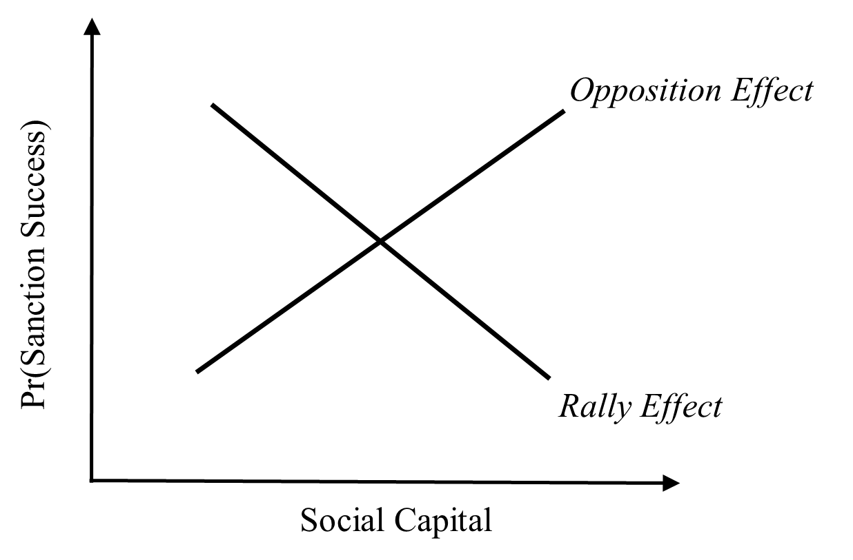

**Figure 1.** Offsetting effects of social capital on the likelihood sanctions are successful.

Figure 1 summarizes our theoretical expectations based on the conflicting *opposition effect* and *rally effect* of social capital. The success of sanctions depends on degree of social capital in the sanctioned country. Social capital helps reveal citizen preferences effectively through collective action, which can function negatively as a veto constraint (*opposition effect*) or positively as defenders of the sanctioned country’s leader (*rally effect*).

The question now shifts to determining which effect is greater. As the degree of social capital increases, will the afflicted populace mobilize, oppose the leader’s policy, and show the *opposition effect*? Or will the populace support its leader in defying sanctions through the *rally effect*? It is unclear as to which effect prevails as social capital increases. We posit that both effects are theoretically plausible and that empirical evidence will show which outweighs the other.

**Data, variables, and methods**

*Data*

We subject our theory of social capital, information, and sanctions to empirical tests using three datasets. One is the Threat and Imposition of Sanctions (TIES) project (Version 4.0), which covers imposition of sanctions from 1945 to 2005 (Morgan, Bapat, and Krustev, 2009), and another is the dataset from the World Values Survey (WVS). Combining these datasets, we analyze individual instances of sanctions across 1981–2005. WVS has conducted one of the largest cross-national opinion surveys since 1981 regularly, and we utilize its data to operationalize social capital by measuring survey questions related to trust, membership, and confidence. We include countries in all six waves of the WVS. Wave 1 covers 1981–1984, Wave 2 covers 1990–1994, Wave 3 covers 1995–1998, Wave 4 covers 1999–2004, Wave 5 covers 2005–2009, and Wave 6 covers 2010–2014. Although Wave 1 posed survey questions about trust, membership, and confidence to only nine countries, the number rose to 17 in Wave 2, 53 in Wave 3, 40 in Wave 4, 57 in Wave 5, and 59 in Wave 6.[4]

*Variables*

Our dependent variable identifies the success of sanctions as a binary variable using the variable, *Final Outcome*, from TIES data. We define sanctions as successful and assign a value of 1 if the termination of the sanctions leads to “Partial Acquiescence by the Target State,” “Total Acquiescence by Target State,” and “Negotiated Settlement.” We deem other outcomes such as “Capitulation by the sender,” and “Stalemate,” we code them as failed outcomes and, assign them a value of 0.[5]

Our main explanatory variables is the average of each country’s degree of social capital, which is operationalized through one question concerning trust, two concerning membership, and four concerning confidence from all six waves of WVS. Using the online analysis, we merge the averages of responses per wave by country, combining all questions on trust, membership, and confidence and using their mean scores. For example, if 38.4% of survey respondents answered, “Most people can be trusted,” we coded it as 38.4 of people who maintain feelings of general trust. Details for each question per category appear below.

All waves pose the same question for trust and confidence. The principal question concerning general trust include the following: *Generally speaking, would you say that most people can be trusted or that you need to be very careful in dealing with people?* Answers entail *Most people can be trusted, Can’t be too careful,* and *No answer*.

Membership is separated into two questions. Waves 1, 3, and 5 use one set of formatted question and waves 2 and 4 use another. Waves 1, 3, and 5 ask the following: *Please look carefully at the following list of voluntary organisations and activities and say which, if any, do you belong to.* Waves 2 and 4 ask: *Now I am going to read out a list of voluntary organizations; for each one, could you tell me whether you are a member, an active member, or not a member of that type of organization?* The first membership question has three answer choices (*active member, inactive member,* and *not a member*). Questions for Waves 2 and 4 offer two options (*belongs, do not belong*). We use both questions to observe survey membership in political parties and professional associations. Because the number of answer choices for each question differs, we combine active and inactive membership from the first set of questions to maintain consistency.

Confidence entails one question in all waves: *I am going to name numerous organisations. For each one, could you tell me how much confidence you have in them: is it a great deal of confidence, quite a lot of confidence, not very much confidence, or none at all?* We measure confidence in political parties, government, parliament, and the justice system.

As control variables, we include political (*Alliance* and *Target Democracy*), economic (*Target ln(GDPPC)*), issue (*Issue Salience*), and geographical variables (*Contiguity* and *Distance*). *Alliance* uses the Correlates of War Formal Alliance dataset (Gibler, 2009). If the sanctioned country is not allied with the sanctioning country, the variable is coded 0. *Target Democracy* measures the degree of democracy in the sanctioned country based on the V-Dem project’s Electoral democracy index. It measures how much the ideal of electoral democracy is achieved in a given year and given country. The variable varies from 0 (least democratic) to 1 (most democratic) based on the concept of *Polyarchy* (Coppedge et al. 2020). *Target GDP per capita* is the logged GDP per capita of the sanctioned country, which measures its economic power. *Issue* *salience* identifies the leading institutions in the country that initiates sanctions. They include bureaucracy, legislature, executive or government, judiciary, and others. We expect the salience of the issue at stake to increase when legislative or executive branches, rather than a bureaucracy or judiciary, initiates sanctions. Elected politicians have incentives to publicize opponents’ positions and their own. Thus, *Issue salience* equals 1 if *Sanction Identity* in the TIES dataset indicates legislature, executive, or government and 0 otherwise. *Distance* measures the physical distance between the sanctioning and sanctioned countries to control for geographical proximity, as neighboring countries can be more exposed to sanctions than remote countries. We use the logged values of *Distance*. Contiguity is a six-category variable that measures the contiguity between the sanctioning and sanctioned countries. The Appendix summarizes statistics for all variables.

*Methods*

Because our dependent variable is binary, we use probit analysis with robust standard errors to evaluate the hypotheses.

**Results**

**Table 1.** Effect of social capital (*Trust* and *Membership*) on success of sanctions

|  |  |  |  |
| --- | --- | --- | --- |
| DV = *Successful sanctions* | Model 1 | Model 2 | Model 3 |
| *Trust* | −0.02* |  |  |
|  | (0.01) |  |  |
| *Membership: Political Party* |  | −0.03 |  |
|  |  | (0.03) |  |
| *Membership: Prof. Association* |  |  | −0.03 |
|  |  |  | (0.03) |
| *Contiguity* | −2.69* | −1.65 | −1.59 |
|  | (1.47) | (2.01) | (2.02) |
| *Distance* | 1.55* | 0.90 | 0.88 |
|  | (0.86) | (1.18) | (1.18) |
| *Target ln(GDPPC)* | −0.07 | 0.45 | 0.43 |
|  | (0.34) | (0.37) | (0.38) |
| *Issue Salience* | 0.89** | 1.32** | 1.38** |
|  | (0.42) | (0.47) | (0.49) |
| *Alliance* | 0.77* | 0.20 | 0.44 |
|  | (0.40) | (0.54) | (0.49) |
| *Target Democracy* | −1.33 | −1.31 | −1.24 |
|  | (0.99) | (0.93) | (0.91) |
| *Constant* | 3.14 | −2.37 | −2.52 |
|  | (3.01) | (4.01) | (4.22) |
| N  Pseudo R-squared  Log-likelihood | 116  0.1428  −49.521 | 94  0.1691  −35.633 | 94  0.1691  −35.632 |
| Standard errors in parentheses. | | | |
| * p < 0.1, ** p < 0.05 | | | |

Table 1 reports the regression results when using *Trust* (Model 1)*, Membership: Political Party* (Model 2)*,* and *Membership: Prof. Association* (Model 3) as main explanatory variables for social capital. All three models show that coefficients for the main explanatory variables are negative and significant at 5% in Models 1 and 2 and at 10% for Model 3. This finding implies that as trust, membership in political parties, and political associations in the sanctioned country increase—i.e., as the degree of social capital increases in the sanctioned country—the likelihood sanctions are successful declines significantly.

It is clear from Table 1 that the *rally effect* is more prominent than the *opposition effect*. The sanctioned populace is more likely to support its leader in defying sanctions. We have no evidence whether or how intensively the leader of the sanctioned country is involved in persuading the populace to rally support. We do know that the *opposition effect* is not functioning as we might expect. It seems that, on average, social capital prompts the sanctioned populace to sympathize with its leader’s defiance of sanctions rather than regarding them as an unnecessary tariff to be abolished. Thus, it would be poor counsel to advise strengthening or expanding sanctions to incite the populace to unite against its leader for concessions. Such counsel ignores that the *rally effect* dominates the *opposition effect* in the sanctioned country.

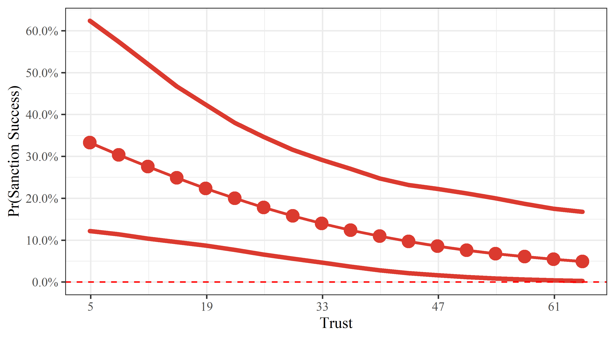

**Figure 2**. Predicted probability of successful sanctions as a function of *Trust*.

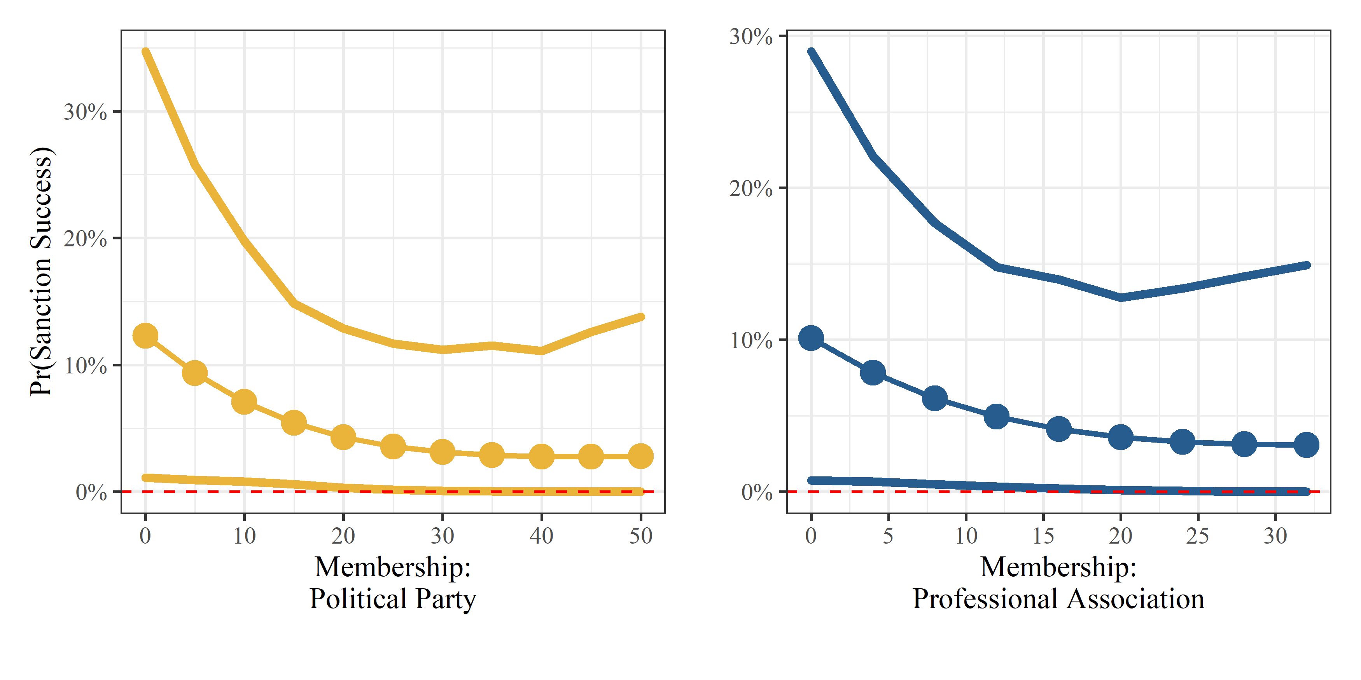

**Figure 3**. Predicted probability of successful sanctions as a function of *Membership: Political Party and Professional Association.*

Figures 2 and 3 display predicted probabilities of successful sanctions as a function of the three social capital measures while setting all other variables to their means: *Trust* (Figure 2), *Membership: Political Party*, and *Membership: Professional Association* (Figure 3). The figures partially confirm the *Rally Effect Hypothesis*: successful sanctions are less likely as social capital increases with respect to *Trust*. *Trust* reduces the success rate of sanctions by more than 30% when we use the variable using its lowest and highest values.

Although two membership variables are not statistically significant, their patterns are similar: membership in political parties and associations reduce the likelihood that sanctions will succeed by about 10% and 7%, respectively. This finding implies that the populace tends to blame the sanctioning country and, more important, this tendency becomes more prominent as capacity for mobilization increases.

Table 2 displays estimation results for the success of sanctions after using confidence variables in WVS to measure social capital. We use *Confidence in Political Party* (Model 1)*, Government* (Model 2)*, Parliament* (Model 3)*,* and *Courts* (Model 4)*.*We ask how confidence of the sanctioned populace in key institutions affects the likelihood that the leader of the sanctioned country resists sanctions. These findings endorse those in Table 1. Statistical evidence confirms the *Rally Effect Hypothesis*. As confidence in political institutions increases in the sanctioned country, its leader appears less likely to make concessions, reducing the likelihood that sanctions succeed.

**Table 2.** Effect of social capital (*Confidence*) on success of sanctions.

|  |  |  |  |  |
| --- | --- | --- | --- | --- |
|  | Model 1 | Model 2 | Model 3 | Model 4 |
| *Confidence in Political Party* | −0.02 |  |  |  |
|  | (0.04) |  |  |  |
| *Confidence in Government* |  | −0.02 |  |  |
|  |  | (0.02) |  |  |
| *Confidence in Parliament* |  |  | −0.02 |  |
|  |  |  | (0.03) |  |
| *Confidence in Courts* |  |  |  | −0.03 |
|  |  |  |  | (0.02) |
| *Contiguity* | −2.46* | −2.3* | −2.6* | −0.57 |
|  | (1.40) | (1.30) | (1.47) | (1.9) |
| *Distance* | 1.43* | 1.37* | 1.53* | 0.30 |
|  | (0.81) | (0.75) | (0.86) | (1.12) |
| *Target ln(GDPPC)* | -0.14 | −0.15 | −0.22 | −0.51 |
|  | (0.39) | (0.36) | (0.41) | (0.61) |
| *Issue Salience* | 0.32 | 0.58 | 0.64 | 1.09* |
|  | (0.46) | (0.58) | (0.41) | (0.57) |
| *Alliance* | 0.83 | 0.79 | 0.88* | 0.8 |
|  | (0.53) | (0.48) | (0.48) | (0.59) |
| *Target Democracy* | −1.43 | −2.73 | −1.75 | −0.69 |
|  | (1.28) | (1.52) | (1.26) | (1.3) |
| *Constant* | 3.16 | 3.68 | 4.06 | 4.53 |
|  | (3.78) | (3.76) | 4.12) | (5.2) |
| N  Pseudo R-squared  Log-likelihood | 76  0.0926  −36.656 | 68  0.1252  −32.456 | 102  0.0945  −48.149 | 65  0.1862  −29.009 |
| Standard errors in parentheses. | | | | |
| * p < 0.1, ** p < 0.05 | | | | |

Combined with results of Table 1, social capital measured by dimensions of trust, membership, and confidence point in favor of the *rally effect*. Even though the sanctioned populace must suffer economic hardship, people seem willing to defend their leader.

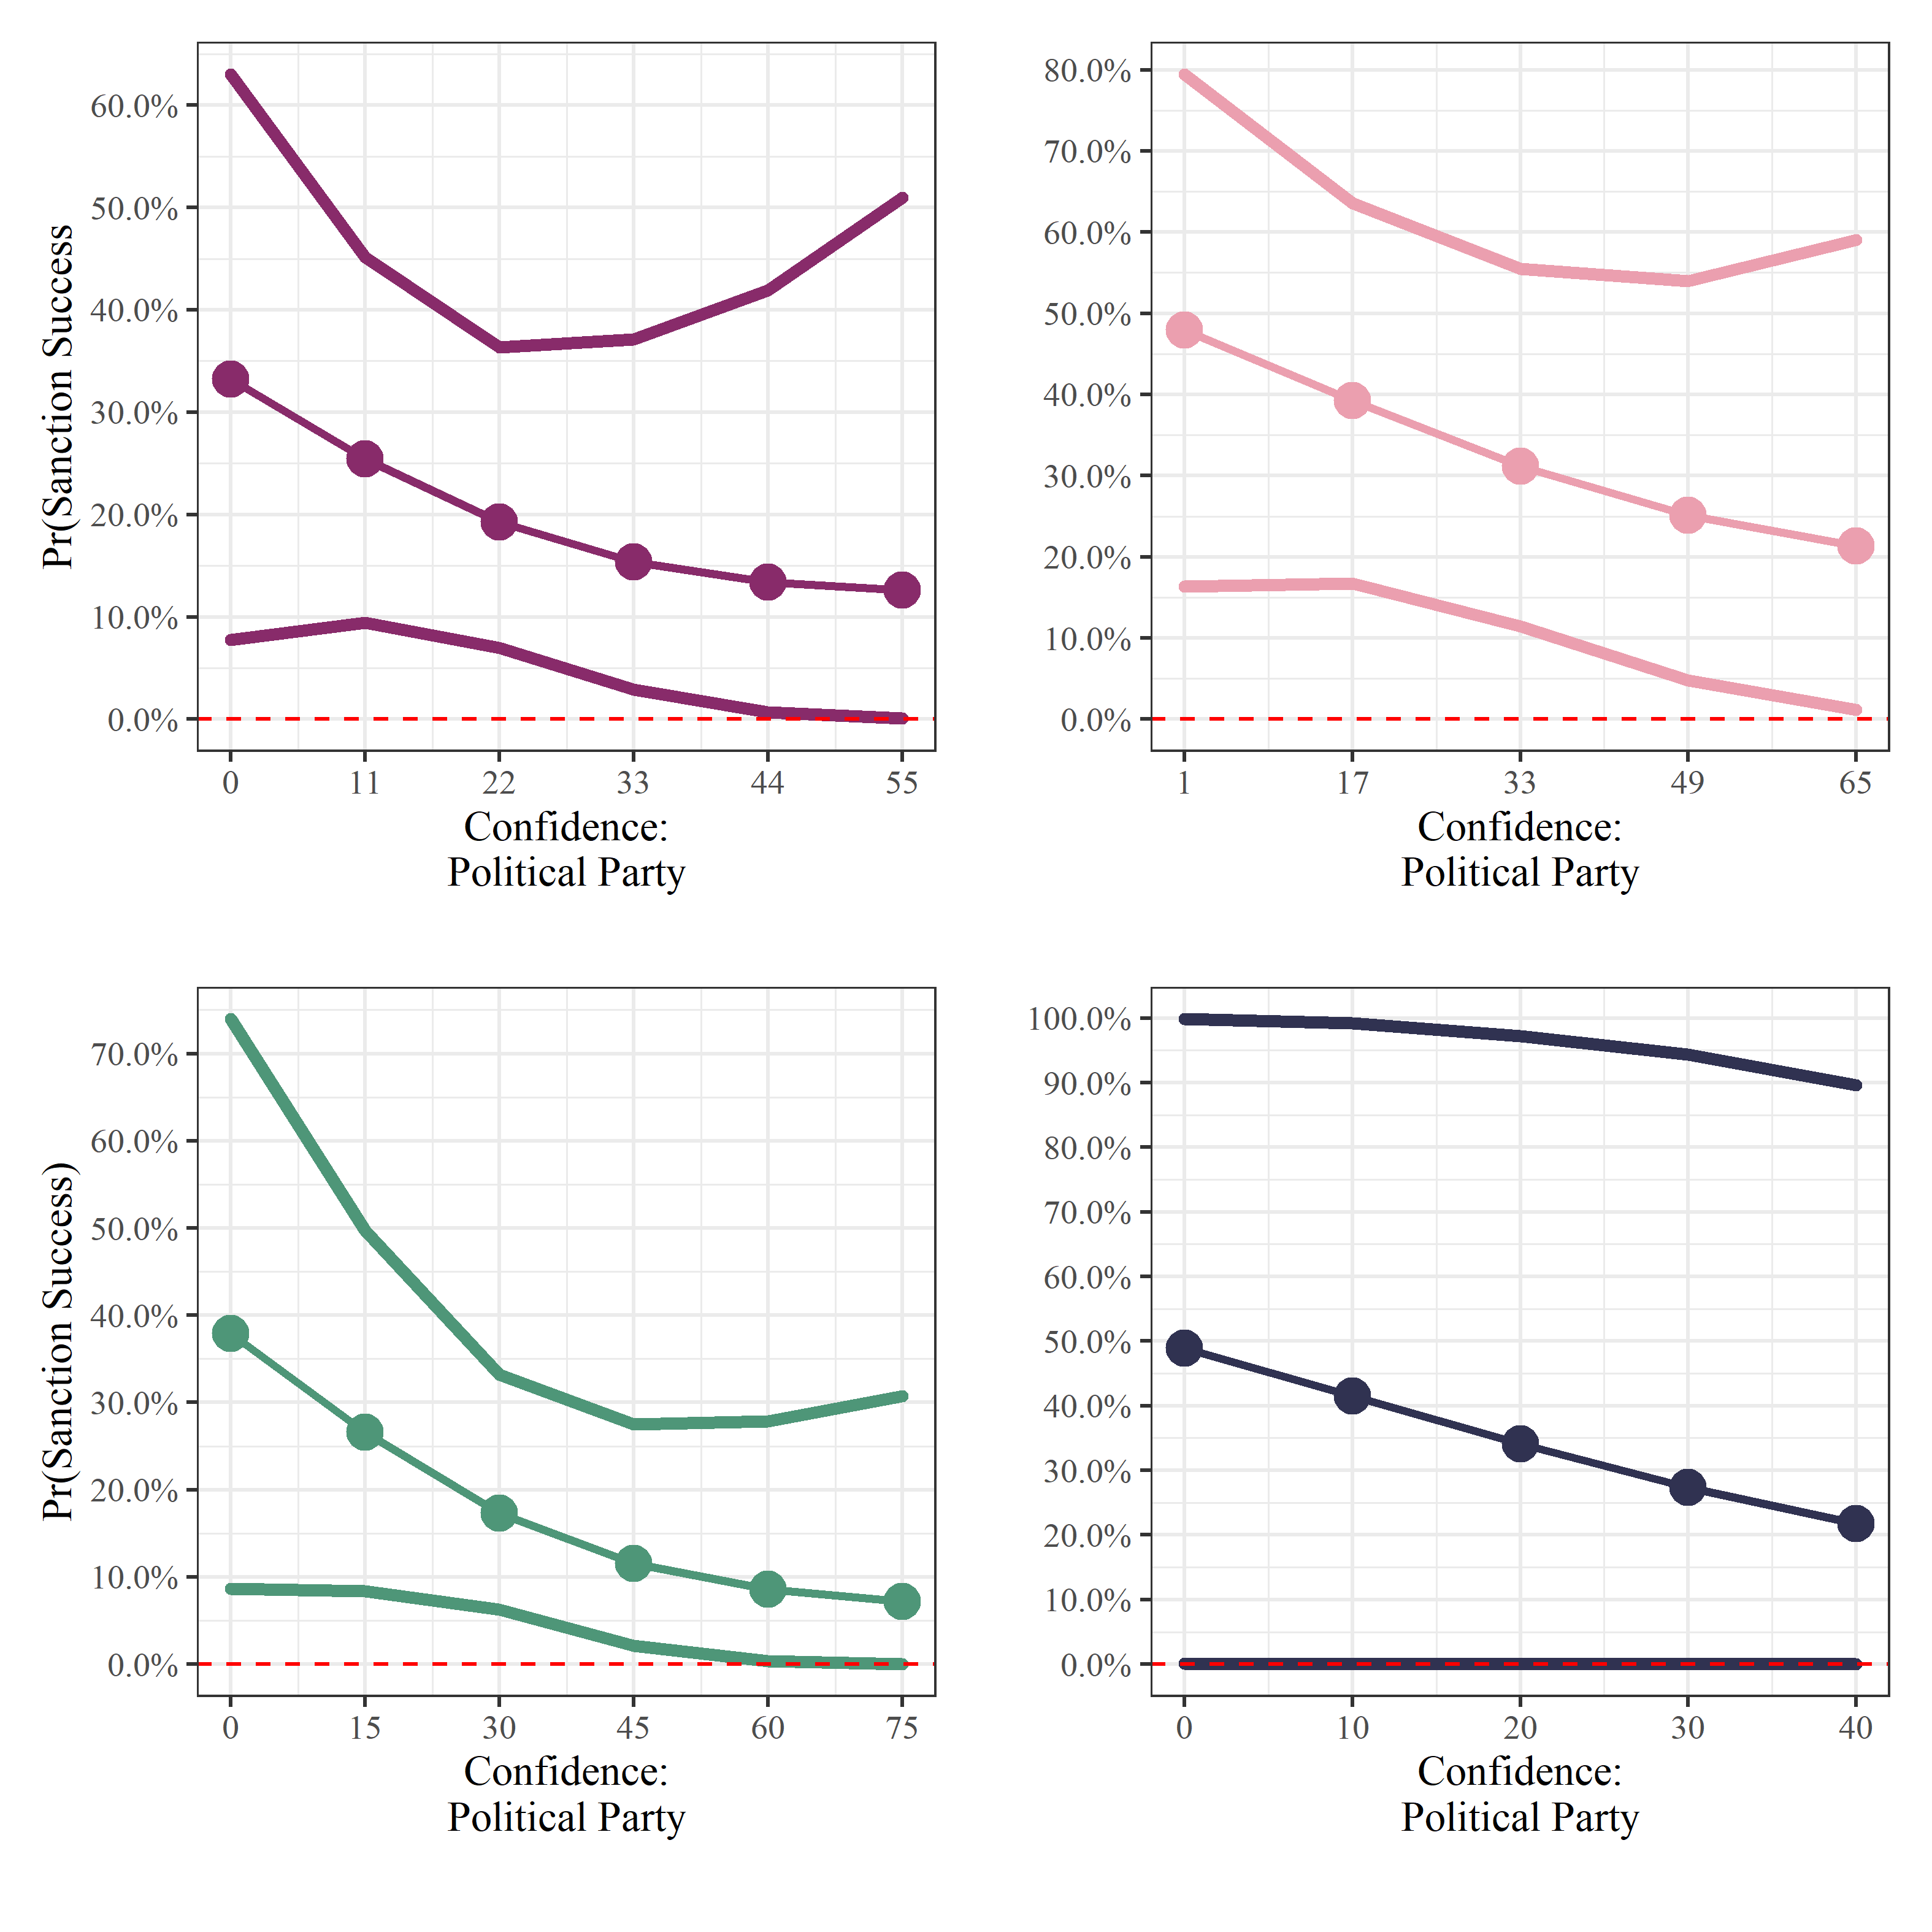

**Figure 4.** Predicted probability of successful sanctions as a function of confidence: *Professional Party, Government, Parliaments,* and *Courts.*

Figure 4 displays the substantive effects of confidence variables on the predicted probability of sanctions being successful. Each subfigure shows that when we vary confidence variables from their minimum to maximum values, the predicted probability of successful sanctions drops by about 17% to 26% on average. Although the confidence variables do not show statistical significance, their patterns convey that it is more likely to support the *Rally Effect Hypothesis* over the *Opposition Effect Hypothesis*.

In sum, we provide a micro-foundation for the rally-round-the-flag effect. When the sanctioned country has internal cohesion through trust, membership in political parties or associations, and confidence in institutions, the sanctioned populace generally supports its leader. Social capital is useful for the leader of the sanctioned country to fight sanctions. The likelihood of successful sanctions is more likely to diminish as a result.

**Discussion**

Our results imply that high social capital can support the target government and deter the success of sanctions. WVS data provide no information about North Korea, but numerous sources show that job losses are the major negative effect of sanctions affecting North Korea’s populace. U.N. Resolution 2270 on March 2nd, 2016 was reinforced by closing the Kaesong industrial complex, which left 50,000 North Koreans unemployed and deprived North Korea of $100 million annually. Furthermore, U.N. Resolution 2375 passed on September 11th, 2017 also prohibited a substantial part of North Korea’s imports and exports, as well as joint ventures and labor exports with Russia and China, increasing the amount of jobless people. Despite these harsh conditions, there was no collective opposition from citizens within North Korea. Scholars often assume social capital does not exist in North Korea because the government is notoriously repressive. However, interviews with North Korean refugees reveal that trust and community bonds exist but are not maintained from the bottom up as is more typical of social capital in democratic countries.

According to refugees, the most feared organization in North Korea is the State Security Department (SSD), which acts as secret police, operating concentration camps and monitoring and identifying “defectors” on a daily basis who express dissatisfaction with the regime. It itself imposes a social network, contriving social capital, creating communities that spy on families and exiling people who oppose government policies to prevent dispersion of ideas (Scobell, 2005; Mazarr, 2007). With the use of the “Weekly Life Review Session,” the SSD was able to further control society by making people monitor and alert each other. Although known as the “Weekly Life Review Session,” there is an accurate descriptive translation that is more recognized, which is “Self-Criticism and Mutual-Criticism Session” (Lankov, 2013).

Furthermore, this type of control was also present in the media. Just like Russia’s *Pravda*, or China’s *Renimn RiBao*, North Korea has the *Rodong Shinmun* editorial which plays a crucial role in effectively spreading and engraving Kim Jong-un and the North Korean regime’s messages to its citizens (Ford, 2018). The *Rodong Shinmun* editorials introduce and reinforce Kim Jong-un’s messages while also showing the highest levels of thinking of the Party.

In addition, as it is already well known, North Korea’s citizens have high levels of pride for living according to the spirit of “Juche” which enables good socio-structural condition for collectivism to develop. The agricultural production through cooperative farms, and collective activities from various organizations under the Worker’s Party have a fundamental trait in North Korea’s social capital. As such, Kim Jong- un and politicians create a controlled rally effect by forcefully creating and imposing social capital that support them.

North Korea’s political elite dominates the allocation of resources and flow of information in nearly all segments of society. Reports from the SSD, however, show strong community bonds and support for government. These feelings may be imposed exogenously, as people know SSD monitors them, but they are confirmed by refugees who insist that trust and community bonds persist. Moreover, the government has manipulated the populace into believing it is victimized by international forces. This enhances trust and community bonds and raises popular support for the country’s policies. The populace suffers under sanctions, losing work and income, paying inflating prices because imports are limited, and being deprived of aid, but networks of associations within the community sustain rather than oppose the regime. Thus social capital is engineered to support the regime and to create opposition toward sanctions. Because social capital is extensively manipulated, sanctions have been unsuccessful, and the rally effect operates in North Korea.

As an illustration of its effectiveness, in June 2016 the North Korean government initiated a 200-day mass mobilization following a similar 70-day mobilization in May. Both propaganda-driven events began after the U.N. strengthened its sanctions following North Korea’s 2016 nuclear test. Originally intended to kick off a new five-year economic plan, the mobilization encouraged North Koreans to remain opposed to sanctions and to support the regime. Although North Koreans are more or less obligated to participate, the campaign’s leaders encourage and praise ordinary people to instill national pride and to urge them to persevere despite strengthened sanctions. These mass mobilizations generate support for the government and social capital-building nationalism.

**Conclusion**

This empirical study has illustrated that the influence of social capital can exert two unifying but contradictory effects on whether economic sanctions are successful. The *opposition effect* posits that sanctions are likely to be more successful as social capital increases, whereas the *rally effect* contends that sanctions are less likely to be successful as social capital increases. We investigated these effects using data from the WVS to measure trust, membership, and confidence as the main independent variable of social capital and TIES for the dependent variable of successful sanctions. After adding control variables and evaluating hypotheses using probit analysis with robust standard errors, we found that the empirical data supports *Rally Effect Hypothesis* over the *Opposition Effect*. As the degree of social capital increases in a sanctioned country, the likelihood of successful sanctions declines significantly. Our findings imply that comprehensive sanctions aimed at the populace will not engender immediate opposition against its leader, as conventional wisdom suggests. The rally effect can present an additional impediment to be considered when designing sanctions.

Although insightful, finding correlations and imputing causality between social capital and sanctions is a new field that lacks the benefit of prior research. The operationalization of social capital may be open to empirical disagreements as we incorporate the new facet of confidence. However, our measurements can be justified under the notion that the forms of confidence we include capture feelings about both government and society that are factors in understanding social capital.

**References**

Adrian U, Ang J and Peksen D. (2007) When do economic sanctions work? Asymmetric perceptions, issue salience, and outcomes. *Political Research Quarterly* 60(1): 135–145.

Allen, SH (2005) The determinants of economic successful sanctions and failure. *International Interactions* 31(2): 117–138.

Allen, Susan Hannah. (2008) The Domestic Political Costs of Economic Sanctions. Journal of Conflict Resolution 52(6): 916-944.

Almond GA and Verba S (1963) *The Civic Culture: Political Attitudes and Democracy in Five Nations*. Princeton, NJ: Princeton University Press.

Baldwin, DA (1985) *Economic Statecraft*. Princeton University Press.

Barber, J (1979) Economic sanctions as a policy instrument. *International Affairs (Royal Institute of International Affairs)* 55(3): 367–384.

BBC news. (2014). *Iran sanctions: U.S. moves to isolate ‘major’ banks.* Retrieved from <https://www.bbc.com/news/world-middle-east-54476894>.

Bourdieu P (1986) The forms of social capital. In: Richardson JG (ed) *Handbook of Theory and Research for the Sociology of Education*. NY: Greenwood Press, pp. 241–258.

Brehm J and Rahn W (1997) Individual-level evidence for the causes and consequences of social capital. *American Journal of Political Science* 41(3): 999–1023.

Brooks, RA (2002) Sanctions and regime type: what works, and when? *Security Studies* 11(4): 1–50.

Bueno de Mesquita, Bruce, James D. Morrow, Randolph M. Siverson, and Alastair Smith. (1999) An Institutional Explanation of the Democratic Peace. The American Political Science Review 93(4): 791-807.

Byman, D., and Lind, J. (2010) Pyongyang’s Survival Strategy: Tools of Authoritarian Control in North Korea. *International Security* 35(1): 44-74.

Chen, Jidong, and Xu, Yiquing. (2015) Information Manipulation and Reform in Authoritarian Regimes. *Political Science Research and Methods.* 5(1): 163-178.

Coleman. J.S. (1988) Social capital in the creation of human capital. *American Journal of Sociology* 94(S1): 95.

Coppedge, Michael, John Gerring, Carl Henrik Knutsen, Staffan I. Lindberg, Jan Teorell, David Altman, Michael Bernhard, M. Steven Fish, Adam Glynn, Allen Hicken, Anna Lührmann, Kyle L. Marquardt, Kelly McMann, Pamela Paxton, Daniel Pemstein, Brigitte Seim, Rachel Sigman, Svend-Erik Skaaning, Jeffrey Staton, Agnes Cornell, Lisa Gastaldi, Haakon Gjerløw, Valeriya Mechkova, Johannes von Römer, Aksel Sundtröm, Eitan Tzelgov, Luca Uberti, Yi-ting Wang, Tore Wig, and Daniel Ziblatt. (2020). “V-Dem Codebook v10.” *Varieties of Democracy (V-Dem) Project.*

Cortright, D and Lopez GA (eds) (2002) *Smart Sanctions: Targeting Economic Statecraft*. Rowman & Littlefield.

Cortright, D and Lopez GA (eds) (1995) *Economic Sanctions: Panacea or Peacebuilding in a Post-Cold War World.* Boulder, Colo.: Westview Press.

Dalton R and Welzel C (eds) (2015) From allegiant to assertive citizens. In: *The Civic Culture Transformed: From Allegiant to Assertive Citizens*. Cambridge University Press, pp. 282–306.

Dashti-Gibson J, Davis P and Radcliff B (1997) On the determinants of the success of economic sanctions: an empirical analysis. *American Journal of Political Science* 41(2): 608–618.

Doxey M (1971) The Rhodesian sanctions experiment. *Year Book of World Affairs* 25: 142–162.

Drezner, D.W. (1999) *The Sanctions Paradox: Economic Statecraft and International Relations.* Cambridge University Press.

Early BR (2009) Sleeping with your friends’ enemies: an explanation of sanctions‐busting trade. *International Studies Quarterly* 53(1): 49–71.

Ford, Glyn. (2018) *Talking to North Korea: Ending the Nuclear Standoff*. London: Pluto Press.

Frank, Ruediger. (2006) The Political Economy of Sanctions against North Korea. *Asian Perspective* 30(3): 5-36.

Fukuyama F (1995) *Trust*. NY: Free Press.

Galtung J (1967) On the effects of international economic sanctions, with examples from the case of Rhodesia. *World Politics* 19(3): 378–416.

Gibler DM (2009) *International Military Alliances, 1648–2008*. C.Q. Press.

Gurr TR (1970) *Why Men Rebel*. Princeton, NJ: Princeton University Press.

Hart RA (2000) Democracy and the successful use of economic sanctions. *Political Research Quarterly* 53(2): 267–284.

Hufbauer GC et al. (2007) *Economic Sanctions Reconsidered*. 3rd edition. Washington, DC: Peterson Institute for International Economics.

Jing C, Kaempfer W.H. and Lowenberg AD (2003) Instrument choice and the effectiveness of international sanctions: a simultaneous equations approach. *Journal of Peace Research* 40(5): 519–535.

Kaempfer W.H. and Lowenberg AD (1988) The theory of international economic sanctions: a public choice approach. *The American Economic Review* 78(4): 786–793.

Kaempfer W.H. and Lowenberg AD (1992) *International Economic Sanctions: A Public Choice Perspective*. Boulder, CO: Westview.

King, Gary, Jennifer Pan, and Margaret E. Roberts (2013). How Censorship in China Allows Government Criticism but Silences Collectively Expression.” *American Political Science Review* 107(2): 1-18.

Lacy D and Niou E (2004) A theory of economic sanctions and issue linkage: the roles of preferences, information, and threats. *Journal of Politics* 66(1): 25–42.

Lankov, Andrei. (2013). *The Real North Korea: Life and Politics in the Failed Stalinist Utopia*. New York: Oxford University Press.

Lektzian D and Souva M (2003) The economic peace between democracies: economic sanctions and domestic institutions. *Journal of Peace Research* 40(6): 641–660.

Lektzian D and Souva M (2007) An institutional theory of sanctions onset and success. *Journal of Conflict Resolution* 51(6): 848–871.

Lektzian, David, and Mark Souva. (2007) An Institutional Theory of Sanctions Onset and Success. The Journal of Conflict Resolution 51(6): 848-871.

Mazarr, Michael J (2007) The Long Road to Pyongyang. *Foreign Affairs* 86(5): 75–94.

McGillivray F and Stam AC (2004) Political institutions, coercive diplomacy, and the duration of economic sanctions. *Journal of Conflict Resolution* 48(2): 154–172.

McLean EV and Whang T (2019) Economic Sanctions and Government Spending Adjustments: The Case of Disaster Preparedness. *British Journal of Political Science*: 1-18.

Morgan CT and Schwebach VL (1997) Fools suffer gladly: the use of economic sanctions in international crises. *International Studies Quarterly* 41(1): 27–50.

Morgan CT, Bapat NA and Krustev V (2009) The threat and imposition of economic sanctions, 1971–2000. *Conflict Management and Peace Science* 26(1): 92–110.

Morgan CT, Krustev V and Bapat NA (2006) *Threat and Imposition of Sanctions (TIES)*. University of North Carolina.

Nooruddin I (2002) Modeling selection bias in studies of sanctions efficacy. *International Interactions* 28(1): 59–75.

Pape RA (1997) Why economic sanctions do not work. *International Security* 22(2): 90–136.

Pape, Robert A. (1997) Why Economic Sanctions Do Not Work. International Security 22(2): 90-136.

Porter RC (1979) International trade and investment sanctions potential impact on the South African economy. *Journal of Conflict Resolution* 23(4): 579–612

Portes A (1998) Social capital: its origins and applications in modern sociology. *Annual Review of Sociology* 24: 1–24.

Putnam RD (1995a) Bowling alone: America’s declining social capital. *Journal of Democracy* 6(1): 65–78.

Putnam RD (1995b) Tuning in, tuning out: the strange disappearance of social capital in America. *P.S.: Political Science and Politics* 28(4): 664–683.

Putnam RD, Leonardi R and Nanetti R. (1993) *Making Democracy Work: Civic Traditions in Modern Italy*. Princeton, NJ: Princeton University Press.

Putnam, RD (2000) *Bowling Alone: The Collapse and Revival of American Community*. Simon & Schuster.

Quibria MG. (2003) The puzzle of social capital: a critical review, *ERD Working Paper No. 40,* Asian Development Bank.

Renwick R (1981) *Economic Sanctions*. Center for International Affairs, Harvard University.

Rowe DM (2000) Economic sanctions, domestic politics and the decline of Rhodesian tobacco, 1965–79. *Sanctions as Economic Statecraft: Theory and Practice* 131–157.

Scobell, Andrew (2005) Making Sense of North Korea. *Asian Security* 1(3): 245–266.

Spaniel, William, and Bradley C. Smith. (2015) Sanctions, Uncertainty, and leader Tenure. International Studies Quarterly 59: 735-749.

Stier, S. (2015). Democracy, Autocracy and the News: The impact of regime type on media freedom. Democratization, 22(7), 1273–1295.

Tostensen A and Bull B (2002) Are smart sanctions feasible? *World Politics* 54(3): 373–403.

Tsebelis G (1990) *Nested Games: Rational Choice in Comparative Politics*. University of California Press.

Tzanakis M (2013) Social capital in Bourdieu’s, Coleman’s and Putnam’s theory: empirical evidence and emergent measurement issues. *Educate Journal* 13(2): 2–23*.*

Wallensteen P (1968) Characteristics of economic sanctions. *Journal of Peace Research* 248–267.

Wood, Reed M. (2008) “A Hand upon the Throat of the Nation”: Economic Sanctions and State Repression, 1976-2001. International Studies Quarterly 52: 489-513.

**Appendix A: Summary Statistics for Variables**

|  |  |  |  |  |  |
| --- | --- | --- | --- | --- | --- |
| Variable | Obs. | Mean | S.D. | Min | Max |
| *Successful sanctions* | 116 | 0.20 | 0.4 | 0 | 1 |
| *Trust* | 116 | 30.01 | 14.58 | 4.9 | 59.4 |
| *Membership: Political Party* | 94 | 10.76 | 10.3 | 0 | 45.5 |
| *Membership: Political Association* | 94 | 8.92 | 6.96 | 0 | 25.7 |
| *Confidence: Government* | 68 | 15.3 | 13.09 | 1.9 | 76.0 |
| *Confidence: Parliament* | 102 | 16.78 | 14.27 | 0.9 | 75.0 |
| *Confidence: Political Party* | 76 | 10.6 | 10.62 | 0.9 | 53.8 |
| *Confidence: Courts* | 65 | 22.75 | 10.7 | 6.7 | 37.3 |
| *Contiguity* | 116 | 5.48 | 1.53 | 1 | 6 |
| *Distance* | 116 | 7.78 | 2.66 | 0 | 9.1 |
| *Target ln(GDPPC)* | 116 | 8.41 | 0.68 | 6.87 | 10.01 |
| *Issue Salience* | 116 | 0.19 | 0.39 | 0 | 1 |
| *Alliance* | 116 | 0.49 | 0.50 | 0 | 1 |
| *Target Democracy* | 116 | 0.49 | 0.25 | 0.08 | 0.88 |

|  |  |  |  |  |  |
| --- | --- | --- | --- | --- | --- |
| **Appendix B: List of WVS Countries** | | | | | |
| **Country** | **Wave** | **Year** | **Country** | **Wave** | **Year** |
| Argentina | 1 | 1984 | Andorra | 5 | 2005 |
| Australia | 1 | 1981 | Argentina | 5 | 2006 |
| Finland | 1 | 1981 | Australia | 5 | 2005 |
| Hungary | 1 | 1982 | Brazil | 5 | 2006 |
| Japan | 1 | 1981 | Bulgaria | 5 | 2005 |
| South Korea | 1 | 1982 | Burkina Faso | 5 | 2007 |
| Mexico | 1 | 1981 | Canada | 5 | 2005 |
| South Africa | 1 | 1982 | Chile | 5 | 2006 |
| Sweden | 1 | 1981 | China | 5 | 2007 |
| United States | 1 | 1981 | Colombia | 5 | 2005 |
| Argentina | 2 | 1991 | Cyprus | 5 | 2006 |
| Belarus | 2 | 1990 | Egypt | 5 | 2008 |
| Brazil | 2 | 1991 | Ethiopia | 5 | 2007 |
| Czech Republic | 2 | 1991 | Finland | 5 | 2005 |
| Chile | 2 | 1990 | France | 5 | 2006 |
| China | 2 | 1990 | Georgia | 5 | 2008 |
| India | 2 | 1990 | Germany | 5 | 2006 |
| Japan | 2 | 1990 | Ghana | 5 | 2007 |
| Mexico | 2 | 1990 | Guatemala | 5 | 2004 |
| Nigeria | 2 | 1990 | Hong Kong | 5 | 2005 |
| Poland | 2 | 1989 | Hungary | 5 | 2009 |
| Russia | 2 | 1990 | India | 5 | 2006 |
| Slovakia | 2 | 1990 | Indonesia | 5 | 2006 |
| South Africa | 2 | 1990 | Iran | 5 | 2005 |
| South Korea | 2 | 1990 | Iraq | 5 | 2006 |
| Spain | 2 | 1990 | Italy | 5 | 2005 |
| Switzerland | 2 | 1989 | Japan | 5 | 2005 |
| Turkey | 2 | 1990 | Jordan | 5 | 2007 |
| Albania | 3 | 1998 | Malaysia | 5 | 2006 |
| Argentina | 3 | 1995 | Mali | 5 | 2007 |
| Armenia | 3 | 1997 | Mexico | 5 | 2005 |
| Australia | 3 | 1995 | Moldova | 5 | 2006 |
| Azerbaijan | 3 | 1997 | Morocco | 5 | 2007 |
| Bangladesh | 3 | 1996 | Netherlands | 5 | 2005 |
| Belarus | 3 | 1996 | New Zealand | 5 | 2004 |
| Bosnia and Herzegovina | 3 | 1998 | Norway | 5 | 2007 |
| Bulgaria | 3 | 1997 | Peru | 5 | 2006 |
| Colombia | 3 | 1997–1998 | Poland | 5 | 2005 |
| Croatia | 3 | 1996 | Romania | 5 | 2005 |
| Czech Republic | 3 | 1995 | Russia | 5 | 2006 |
| Chile | 3 | 1996 | Rwanda | 5 | 2007 |
| China | 3 | 1995 | Serbia & Montenegro | 5 | 2005 |
| Dominican Republic | 3 | 1996 | Slovenia | 5 | 2005 |
| El Salvador | 3 | 1999 | South Africa | 5 | 2006 |
| Estonia | 3 | 1996 | South Korea | 5 | 2005 |
| Finland | 3 | 1996 | Spain | 5 | 2007 |
| Georgia | 3 | 1996 | Sweden | 5 | 2006 |
| Germany (East & West) | 3 | 1997 | Switzerland | 5 | 2007 |
| Great Britain | 3 | 1998 | Taiwan | 5 | 2006 |
| Hungary | 3 | 1998 | Thailand | 5 | 2007 |
| India | 3 | 1995 | Trinidad and Tobago | 5 | 2006 |
| Japan | 3 | 1995 | Turkey | 5 | 2007 |
| Latvia | 3 | 1996 | Ukraine | 5 | 2006 |
| Lithuania | 3 | 1997 | UK | 5 | 2005 |
| Macedonia | 3 | 1998 | United States | 5 | 2006 |
| Mexico | 3 | 1995–1996 | Uruguay | 5 | 2006 |
| Moldova | 3 | 1996 | Vietnam | 5 | 2006 |
| Montenegro | 3 | 1996 | Zambia | 5 | 2007 |
| New Zealand | 3 | 1998 | Algeria | 6 | 2014 |
| Nigeria | 3 | 1995 | Argentina | 6 | 2013 |
| Norway | 3 | 1996 | Armenia | 6 | 2011 |
| Pakistan | 3 | 1997 | Australia | 6 | 2012 |
| Peru | 3 | 1996 | Azerbaijan | 6 | 2011–2012 |
| Philippines | 3 | 1996 | Bahrain | 6 | 2014 |
| Poland | 3 | 1997 | Belarus | 6 | 2011 |
| Puerto Rico | 3 | 1995 | Brazil | 6 | 2014 |
| Romania | 3 | 1998 | Chile | 6 | 2011 |
| Russia | 3 | 1995 | China | 6 | 2012 |
| Serbia | 3 | 1996 | Colombia | 6 | 2012 |
| Slovakia | 3 | 1998 | Cyprus | 6 | 2011 |
| Slovenia | 3 | 1995 | Ecuador | 6 | 2013 |
| South Africa | 3 | 1996 | Egypt | 6 | 2012 |
| South Korea | 3 | 1996 | Estonia | 6 | 2011 |
| Spain | 3 | 1995 | Georgia | 6 | 2014 |
| Sweden | 3 | 1996 | Germany | 6 | 2013 |
| Switzerland | 3 | 1996 | Ghana | 6 | 2011 |
| Taiwan | 3 | 1995 | Hong Kong | 6 | 2013 |
| Turkey | 3 | 1996 | India | 6 | 2014 |
| Ukraine | 3 | 1996 | Iraq | 6 | 2013 |
| United States | 3 | 1995 | Japan | 6 | 2010 |
| Uruguay | 3 | 1996 | Jordan | 6 | 2014 |
| Venezuela | 3 | 1996 | Kazakhstan | 6 | 2011 |
| Albania | 4 | 2002 | Kuwait | 6 | 2013 |
| Algeria | 4 | 2002 | Kyrgyzstan | 6 | 2011 |
| Argentina | 4 | 1999 | Lebanon | 6 | 2013 |
| Bangladesh | 4 | 2002 | Libya | 6 | 2013 |
| Bosnia and Herzegovina | 4 | 2001 | Malaysia | 6 | 2011 |
| Canada | 4 | 2000 | Mexico | 6 | 2012 |
| Chile | 4 | 2000 | Morocco | 6 | 2011 |
| China | 4 | 2001 | Netherlands | 6 | 2012 |
| Egypt | 4 | 2001 | New Zealand | 6 | 2011 |
| India | 4 | 2001 | Nigeria | 6 | 2011 |
| Indonesia | 4 | 2001 | Pakistan | 6 | 2012 |
| Iran | 4 | 2000 | Palestine | 6 | 2013 |
| Iraq | 4 | 2004 | Peru | 6 | 2012 |
| Israel | 4 | 2001 | Philippines | 6 | 2012 |
| Japan | 4 | 2000 | Poland | 6 | 2012 |
| Jordan | 4 | 2001 | Qatar | 6 | 2010 |
| Kyrgyzstan | 4 | 2003 | Romania | 6 | 2012 |
| Macedonia | 4 | 2001 | Russia | 6 | 2011 |
| Mexico | 4 | 2000 | Rwanda | 6 | 2012 |
| Moldova | 4 | 2002 | Singapore | 6 | 2012 |
| Montenegro | 4 | 2001 | Slovenia | 6 | 2011 |
| Morocco | 4 | 2001 | South Africa | 6 | 2013 |
| Nigeria | 4 | 2000 | South Korea | 6 | 2010 |
| Pakistan | 4 | 2001 | Spain | 6 | 2011 |
| Peru | 4 | 2001 | Sweden | 6 | 2011 |
| Philippines | 4 | 2001 | Taiwan | 6 | 2012 |
| Puerto Rico | 4 | 2001 | Thailand | 6 | 2013 |
| Saudi Arabia | 4 | 2003 | Trinidad and Tobago | 6 | 2010 |
| Serbia | 4 | 2001 | Tunisia | 6 | 2013 |
| Singapore | 4 | 2002 | Turkey | 6 | 2011 |
| South Africa | 4 | 2001 | Ukraine | 6 | 2011 |
| South Korea | 4 | 2001 | United States | 6 | 2011 |
| Spain | 4 | 2000 | Uruguay | 6 | 2011 |
| Sweden | 4 | 1999 | Uzbekistan | 6 | 2011 |
| Tanzania | 4 | 2001 | Yemen | 6 | 2013 |
| Turkey | 4 | 2001 | Zimbabwe | 6 | 2011 |
| Uganda | 4 | 2001 |  |  |  |
| United States | 4 | 1999 |  |  |  |
| Venezuela | 4 | 2000 |  |  |  |
| Vietnam | 4 | 2001 |  |  |  |
| Zimbabwe | 4 | 2001 |  |  |  |

1. The recent United Nations Security Council (UNSC) Resolution 2375 included contents such as a Maritime Interdiction of Cargo Vessels, a limit to the import of crude oil, textile, fully completed apparel and coal, as well as a prohibition of exports and joint ventures. By comparing the UNSC Resolution 1718, which was passed after the first nuclear test and the UNSC Resolution 2375, which was passed after the 6th nuclear test, we can clearly see that the range and degree of the economic sanctions have been strengthened.
2. In May 2017, the South Korean government acted upon the appeasement of North Korea and held three Inter-Korean Summit meetings, however, there seems to be no visible progress on the lifting of economic sanctions yet. Furthermore, the U.S.-DPRK Summits in June 2018 and February 2019 both fail to show fundamental change in the sanctions towards North Korea.
3. Note that there are many sanctioned countries that are led by a strongman who dictates the conditions under which social capital is formed.
4. The Appendix lists countries that participated in the survey.
5. Since we assume sanctions are already in place, we exclude outcomes that end at the threat stage.